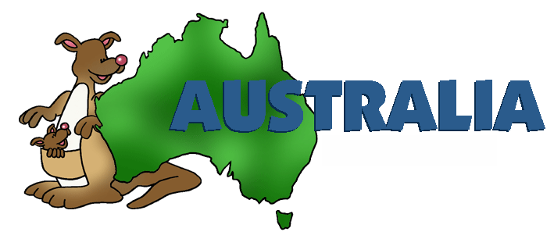
Turtles Homework Summer Term 1
This half term’s topic is ‘Australia’, the aim of this learning is to give pupils an understanding of the geography of Australia, the culture, history and the animals native to Australia. We will also be looking at the similarilarites and differences between Australia and Britain.

Please help your child to complete one or more of the following tasks:
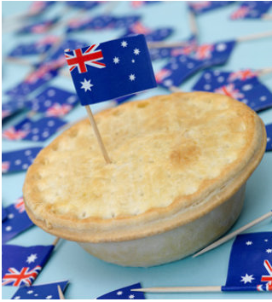
- Investigate on the internet facts about Australia we will not learn in class such as;
Do Australians use pounds and pence like we do in Britain?
What types of food are eaten in Australia?
What sports are popular in Australia?
How can you travel from Britain to Australia?

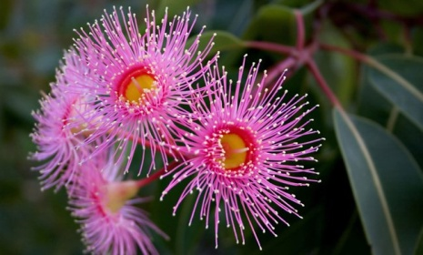
- Draw or paint and Australian flower?

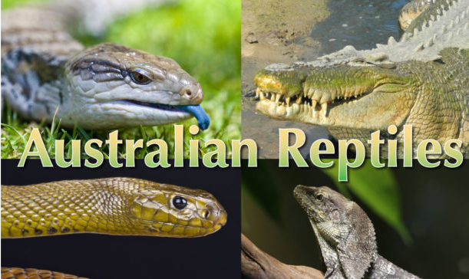

- Create a fact file about two Australian reptiles.

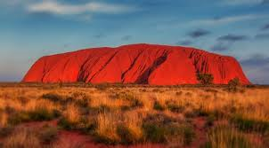

- Make a model of the Australian natural landmark
Uluru.
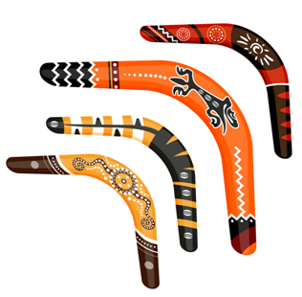
- Make a boomerang and decorate it with traditional patterns. (See pattern below.)
Cut it out and stick it on to cardboard.

